Air Pollution Control System are designed to create A Healthier Environment for Future Generation by Enviropol Engineers Pvt. Ltd.

Press Release: May 04, 2020
ENVIROPOL has been pioneer world-wide in supplying Air Pollution Control (APC) Systems and Bagasse Dryers across industries. Today, it is rated number one amongst few Indian companies for an active presence in the entire spectrum of APC business. Their product portfolio includes Dry Electrostatic Precipitator (DESP), Slurry De-Watering System, Electrified Gravel Bed Precipitator (EGB): -
Electrified Gravel Bed Precipitator (EGB)
The EGB is a high performing dry electrostatic precipitator. The EGB is used as the final stage to remove impurities as tars and fine Sub Micron particulates from process- and flue gases. This Technology is best suited as a polishing filter for sticky and high resistivity dust containing Alkalis like in Palm shell, Palm fiber, EFB and spent wash (Distillery waste) fired Boilers/Incinerators.
This technology has also been used successfully to upgrade existing ESP installations to meet most stringent emission norms in power & cement on coal and lignite fired applications. The EGB design is modular shaped. The nominal capacity of each module is between 10.000- 300.000 m3/h.
The well-designed and proven construction provides high operational reliability, long-term stable collection efficiency, low energy consumption and simple maintenance.
Advantages
- 10-20 times larger collection surface as compared to ESP
- High efficiency on Sub micron particulate
- Smaller Footprints
- Low energy consumption and simple maintenance.
- No production of dirty waters to be treated, nor mud or sludge
- No rapping re entrainments
- Fire resistant
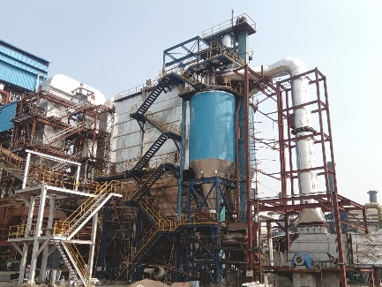
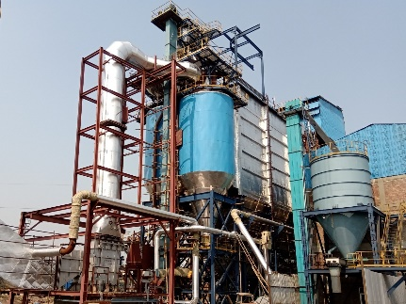
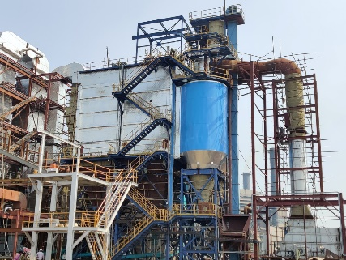

For more information, visit: www.enviropolengineers.in

================================================================================

