FAWENT" S.A. the largest manufacturer ventilation fans and id fans for mines and power plant
Press Release: May 04, 2020

FAWENT S.A. specializes in manufacturing large heavy-duty industrial fans, both centrifugal and axial, mostly intended for power industry but also for mining, chemical, wood, cement and food industries. Over 60 years of experience and regular development of the design and technology thanks to our own designing and research offices, test stands, specialist equipment, design software, strength and stress analysis, finite element analysis, 3D modelling, licences acquired from companies from western part of Europe, close cooperation with scientific institutions and universities allowed our company to become an acclaimed fan supplier on the Polish and European market. This is confirmed by many rewards, distinctions and certificates obtained. The company has provided products and solutions to India, China, Bulgaria, Turkey, Germany, Great Britain, Spain, France, Egypt, Slovakia, Czech Republic and the countries of former Sovient Union and Yugoslavia.
There main products are both axial and centrifugal industrial fans which find application in industry branches such as: power industry primary air, secondary air, induced draught, flue gas recirculation, de-NOx and FGD systems etc.), steel, mining, chemical, food, cement, wood industries etc. They also produce a wide range of fans – from 5K to 10MW motor rated power with the impeller size up to 7000mm.
Axial Fans
General application fans are mostly used in ventilating applications in rooms, dryers, cold stores etc. However, they can be used in other induced-forced draught installations. Flue gas axial fans are mainly used in the steam boiler applications. In case of fans with fixed impeller blades, the performance control is realized by the axial inlet vane control damper hysteres is below:
0,5%) which is adjusted automatically by an actuator. Variable pitch fans find application mostly at power plants as forced draught, induced draught or FGD booster fans. The fans are equipped with hydraulic adjustment units. The blade angle (and simultaneously the fan performance) is controlled while the fan is in operation.

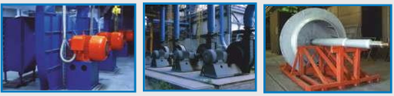

Centrifugal Fans
They are used in a number of industry branches. We provide a wide range of sizes of centrifugal fans. In case of special applications, the fans can be designed for temperature up to 500°C or be manufactured from stainless/acid-resistant steel and be coated with anti-wear material. They are also used as general-purpose fans in various technological processes to provide pressure increase up to 25 000 Pa. Centrifugal conveying fans are intended for pneumatic conveyance of tiny solids and are recommended for wood, textile, food, chemical and ceramic industries. The conveying fans are more immune to dust deposition on the impeller and to erosion.
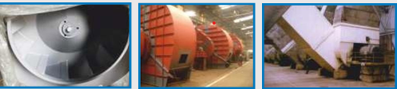

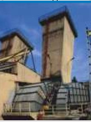
Mine Fans
Centrifugal mine fans are designed for drawing air of temperature up to 60°C, out of underground mines. The casing in the bottom part is made of ferroconcrete, yet the upper part is made of steel. Between the inlet ducts and the fan inlet boxes, there is installed the reversion system consisting of special arrangement of flaps,

For more information, visit: www.fawent.eu

